Deflection Computation:
Moment Area Theorems (M.A.T.)

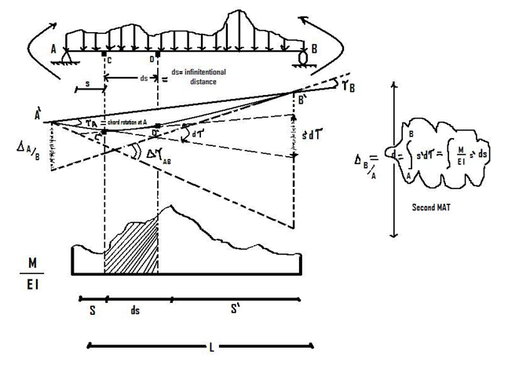
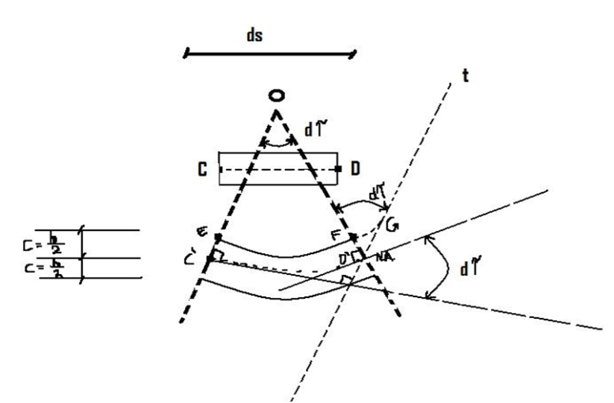
- From point D’, draw line D’t // OC’
- Consider deformed beam segment C’D’ on the neutral Axis (N.A.). The angle between 2 tangent lines at C’ and D’ is d$τ$
Hence: $\hat{C'OD'}$ = $\hat{OD't}$ = d$τ$
- Also curve line EFG is parallel to curve line C’D’
Hence: EFG $≡ ds$
- FG = deformation = εds = $(\frac{σ_{c}}{E}) ds$
Also, FG = Cd$τ$
- Hence $\left(\frac{σ_{c}}{E}\right)ds=Cdτ$
- $\left(\frac{MC}{IE}\right)ds=$C$dτ$
or $dτ=\frac{M}{EI} ds => ∆τ_{AB}= \int{\frac{Mds}{EI}}$ => 1st M.A.T.

Notes:

The first and the second Moment Area Theorems (M.A.T.) will NOT directly give the rotation and displacement of a joint on the beam (or frame).
However, M.A.T will compute the change in angle (such as Δ$τ$ _{AB}) between any 2 points (such as A’, B’) on the beam, and compute the vertical distance (such as d or Δ _{B/A}) between 2 tangent lines (at A’, B’) on the beam.

Example 1: Use Moment Area Theorems (MAT), find the vertical displacement at point G (= $δ$_{G}?) and the rotations θ_{a} and θ_{b} at points A and B.

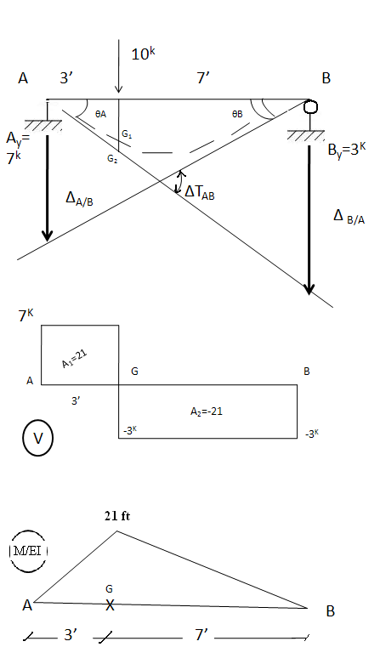

$$δ_{G}≡GG_{1} = (GG_{2}) – G_{1}G_{2} = (3/10 * ∆_{B/A}) – ∆_{G/A}$$
Where:

$∆_{B/A}$ ${}_{=}^{2nd MAT}($Area under $\frac{M}{EI}$diagram$)_{Between B and A}$ * (S’ = distance from B to centroid of area)
Or: $∆_{B/A}= (\frac{1}{2}*{21}^{Kft}*7’)*({S’}_{2}=\frac{2}{3}*7’)+(\frac{1}{2}*{21}^{Kft}*3’)*({S’}_{1}=7’+\frac{1}{3}* 3')$
$$∆_{B/A}= \frac{595}{EI}$$
And $∆_{G/A}$= (area under M/EI diagram$)_{between B and A}$ * (S’ = distance from to centroid of area)
Or $∆_{G/A}=(\frac{1}{2}*{21}^{Kft}*3’)*(S’=\frac{1}{3}*3’)=\frac{31.5}{EI}$

Thus: $δ$_{G} $≡$ $GG_{1}= (\frac{3}{10}*\frac{595}{EI}) - \frac{31.5}{EI}= \frac{147}{EI} = δ_{G}$
θ_{A} = small angle = $\frac{∆_{B/A}}{10'}$= $\frac{59.5}{EI}$= θ_{A}
θ_{B} = small angle = $\frac{∆_{A/B}}{10}=(\frac{1}{10})\{\left(\frac{1}{2}*3’*{21}^{Kft}\right)*\left(\frac{2}{3} *3’\right)+\left(\frac{1}{2} *7’*{21}^{Kft}\right)\left(3'+\frac{1}{3}*7^{'}\right)\}$

Example 2: Use M.A.T to find $θ_{A}, θ_{B},θ_{C}, { δ}_{C}, { δ}_{max}$
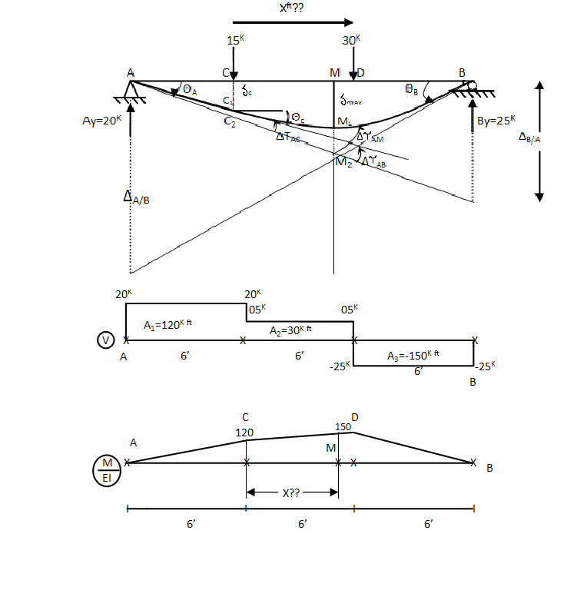
$θ_{A}≅ \frac{∆_{A/B}}{18 ft}$ ……………………. (1)
Where:
Δ_{B/A} = (Area) * (S’= distance from B to centroid area)
Δ_{B/A} = ($\frac{1}{2}$ 6’ * 120) * (S₁’ = 12^{ft} + $\frac{1}{3}$ * 6ft)
+ ($\frac{1}{2}$ * 6’ * 30) * (S₂’ = 6^{ft} + $\frac{1}{3}$ * 6ft)
+ (6’ * 120) * (S₃’= 6ft + $\frac{1}{2}$ * 6ft)
+ ($\frac{1}{2}$ * 6’ * 150) * (S₄’= $\frac{2}{3}$ * 6ft)
or Δ_{B/A}= $\frac{+14,040}{EI}$----------------($1^{B}$)
So: θ_{A}= $\frac{∆_{B/A}}{{18}^{ft}}= \boxed{\frac{780}{EI}= θ_{A} }$

Similarly, $θ_{B}≅ \frac{∆_{A/B}}{{18}^{ft}}$ ……………….(2)

Where: Δ_{A/B}= (Area under $\frac{M }{EI}$ diagram) _{Between A & B} * (S’= distance from A to centroid area)
Δ_{A/B} = ($\frac{1}{2}$ * 6’ * 120) (S₁’= $\frac{2}{3}$ * 6’) + ($\frac{1}{2}$* 6’ * 30) (S₂’= 6ft + $\frac{2}{3}$ * 6ft)
+ (6’ * 120) (S₃’= 6’ + $\frac{1}{2}$* 6’) + ($\frac{1}{2}$* 6’ * 150) (S₄’= 12ft + $\frac{1}{3}$ * 6’)

Δ_{A/B}= (360) (4) + (90) (10) + (720) (9) + (450) (14) = $\frac{+ 15,120}{EI}$

Hence: $\boxed{θ_{B}= \frac{∆_{A/B}}{18}= \frac{840}{EI}}$

Remarks:

- The area between A&B (of the $\frac{M }{EI}$ diagram) has been decomposed into three (3) triangulars and one (1) rectangular
- We can also calculate $θ_{B}$, as following:
$θ_{B}= {}_{=}^{}{{ θ}_{A}+ ∆τ_{AB}}$ (= angle, rotation at A + change in angle between A&B

Where: $∆τ_{AB}≡$(Area of $\frac{M }{EI}$ diagram) _{Between A&B} = ($\frac{1}{2}$* 6’ *120) + ($\frac{1}{2}$*6’ * 30)
+ (6’ *120) + ($\frac{1}{2}$* 6’ * 150)

Or $∆τ_{AB}= \frac{1620}{EI}$

Hence: $θ_{B}= (θ_{A}=_{cw}^{} -\frac{780}{EI}) + (+\frac{1620}{EI}= ∆τ_{AB}) = \boxed{\frac{+840}{EI}= θ_{B}}$

ccw ccw

- Also : $θ_{C}$ $\begin{matrix} \\ =\end{matrix}$ $θ_{A}$ + Δ$τ$ _{AC} ______________________________ (3)
37
Where $θ_{A}$ = $\frac{{}_{- }^{cw}{ 780}}{EI}$
And $∆τ_{AB}=$1st M.A.T = (area under $\frac{M}{EI}$ diagram) _{between A&C}
Δ$τ$ _{AC} = ($\frac{1}{2}$ * $6^{'}$ * 120) = + $\frac{360}{EI}$

Because CCW (see picture previous page)

Hence $θ_{C}$ = ($\frac{-780}{EI})$ + ($\frac{+360}{EI})$ = $\boxed{\frac{{}_{- }^{cw}{ 420}}{EI}= θ_{c}}$

- From the figure, one has:
${ δ}_{c }≡CC_{1}=\left(CC_{2}\right)- [C_{1}C_{2}]$ _________________________________(4)
Or $δ_{c}$ = = ($\frac{6 ft}{18ft}* Δ_{B/A})$ – [$Δ_{C/A}$] _____________________________(5)

Where: $Δ_{C/A}$ = 2nd M.A.T. = (area under $\frac{M}{EI})$_{Between C & A} * ($S^{'}=distance from C to centroid area)$
Or Δ_{C/A} = ($\frac{1}{2}* 6^{'}*120)$ * ($S^{'}= \frac{1}{3}* 6^{'})$ = $\frac{720}{EI}$

Hence: $δ_{c}$ = ($\frac{6}{18}* \frac{14,040}{EI})-\left[\frac{720}{EI}\right] = \boxed{\frac{3960}{EI} = δ_{c}}$

- To find $δ_{max}$ (located at point M on the beam)
Notes Point M (with max. deflection) should be close to ${30}^{K}$ load
38
Rotation at point M ($θ_{M}$) should be zero
We have: $θ_{M}{}_{=}^{}{{ θ}_{A}} +∆τ_{AM}$ ________________________________________(6)
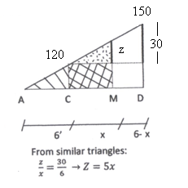
0 = $\left(-\frac{720}{EI}\right)+ {∆τ}_{AM}$ _______________________________________(7)

Where:
$∆τ_{AM}={\left(Area under\frac{M}{EI}\right)}_{Between A\&M}$
${∆τ}_{AM}=\left\{\begin{aligned}\left(\frac{1}{2}*6^{'}*120\right) \\ + (1/2 * x* [z=5x]) \\ +(120*x)\end{aligned}\right.$

${∆τ}_{AM}=\left(360\right)+\left(2.5x^{2}\right)+(120x$) _____________________________(8)
Substitute Eq (8) into Eq (7) to obtain:
0=$\left(-\frac{780}{EI}\right)+\left(\frac{+2.5x^{2}+120x+360}{EI}\right)\boxed{→x=3.28 ft}$
Thus: $δ_{max}≡\left({MM}_{2}\right)-M_{1}M_{2}=\left(\frac{9.26ft}{18ft}*∆_{B/A}\right)-[∆_{M/A}]$__________(9)

Similar triangles

Where: Δ_{M/A} (Use 2nd M.A.T.) = (area under$\frac{M}{EI}$)_{Between M & A} *(S’= distance from M to centroid area)
39

Δ_{M/A} = $\left\{\begin{aligned}\left(\frac{1}{2}* 6^{'}*120\right)*(S_{1}'={3.28}^{'}+ \frac{1}{3}* 6^{'}) \\ + \left(\frac{1}{2}* 3.28*\left[z=5*{3.28}^{'}\right]\right)*({S_{2}}^{'}= \frac{1}{3}* {3.28}^{'}) \\ + \left(120*3.28\right)* {(S}_{3}'= \frac{1}{2}*{3.28}^{'})\end{aligned}\right.$

Δ_{M/A} = (360) * (${5.28}^{'})$ + (1.64) *(16.4)* (1.09) + (393.6) * (1.64) = $\frac{2575.6}{EI}$ = $\frac{2575.6}{EI}$ (10)

Substituting Eq. (10) of Eq. (1^{B}) into Eq. (9), to get:

$δ_{max}= \frac{{9.28}^{ft}}{18ft}$ * $\frac{14,040}{EI}$ - [$\frac{2575.6}{EI}]$

$\boxed{δ_{max}= \frac{4662.8}{EI}}$

Example 3 Use Moment Area Theorems (M.A.T.), find the vertical deflection at joint A ($δ_{A}$) of the frame structure.
41
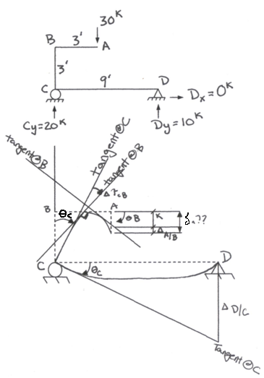

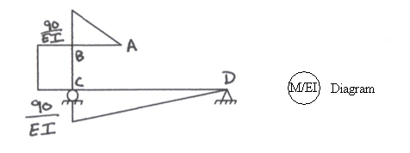

Moments Plotted on Tension Side

Strategies:
- Step1: Compute Δ_{D/C} (use 2nd M.A.T)
- Step 2: $θ_{C }≅ \frac{∆_{D/C}}{9 ft}$

- $Step 3: Compute ∆τ_{CB}$= Change in angle between tangent lines @ C & B (used 1st MAT)

- Step 4: θ_{B} = θ_{C} + $∆τ_{C/B}$

- Step 5: K $≅$ (3^{ft}) * θ_{B}
- Step 6: Compute Δ_{A/B} (use 2nd MAT)

- Step 7: $δ_{A}=K+ ∆_{A/B}$

Step 1: $∆_{D/C}$ = (area of $\frac{M}{EI})_{D→C}$ ) * (S’ = distance from D to centroid area)
41
= ($\frac{1}{2}$* $\frac{90}{EI}$ * 9^{ft}) * (S’ = $\frac{2}{3}$ * 9^{ft}) = $\frac{2430}{EI}$

Step 2: $θ_{C }$ = $\frac{2430}{9EI}$ = $\frac{270}{EI}$

Step 3: $∆τ_{CB}$ = (area of $\frac{M}{EI})_{C→B}$ = $\frac{90}{EI}$ * 3^{ft} = $\frac{270}{EI}$

Step 4: $θ_{B }$ ${}_{=}^{}{(\frac{270}{EI}) }$ + ($\frac{+270}{EI}$) = ($\frac{540}{EI}$)

Step 5: K = 3 * ($\frac{540}{EI}$) = $\frac{1620}{EI}$

Step 6: $∆$ _{A/B} = (area of $\frac{M}{EI})_{A→B}$ * (S’ = distance from A to centroid area)
= ($\frac{1}{2}$ * $\frac{90}{EI}$ * 3^{ft}) * (S’ = $\frac{2}{3}$ * 3^{ft}) = $\frac{270}{EI}$

Step 7: $δ_{A}$ = $\frac{1620}{EI}$ + $\frac{270}{EI}$ = $\boxed{\frac{1890}{EI}=δ_{A}}$

